## Part 1

As a macOS user, I am observing Activity Monitor and creating the report based on that.

### ANS 1.

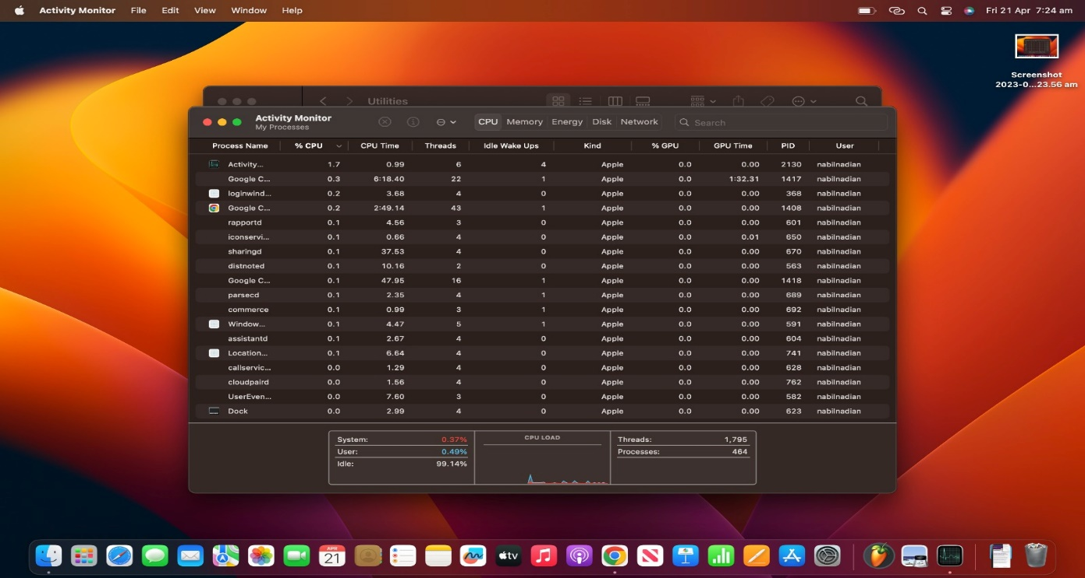

CPU usage of a process.  
1. Process Name: Name of the process currently running.  
2. %CPU: percentage of CPU resources the process is currently using this is calculated according to the total resources available on the CPU.  
3. CPU time: The amount of time the process has spent executing on the CPU.

4. Threads: Number of threads the process is currently running.

5. Idle wake-ups: The number of times the process woke up the CPU to perform a task when the system was idle.

6. Kind: The kind of process that is currently running.

7. %GPU: percentage of GPU resources the process is currently using

8. GPU Time: The amount of time the process has spent executing on the GPU

9 . PID: An unique identifier for each process. This is assigned by the OS.

10. User: The user accounts the process is running under.

### Memory usage of a process.

1. Process Name: Name of the process currently running.
2. Memory: The amount of memory the process is currently using is shown in different units.
3. Memory Pressure: The current memory pressure status of the system.

### ANS 2.

Cloudpaird is a process connected to macOS’s iCloud service. It manages the pairing and authentication of devices that are connected to the iCloud account. This process is used to create a secure connection with the iCloud servers and authenticate the device whenever a new device is used to log in. This helps to access any kind of iCloud data. It usually operates in the background so it doesn’t require any kind of user input.

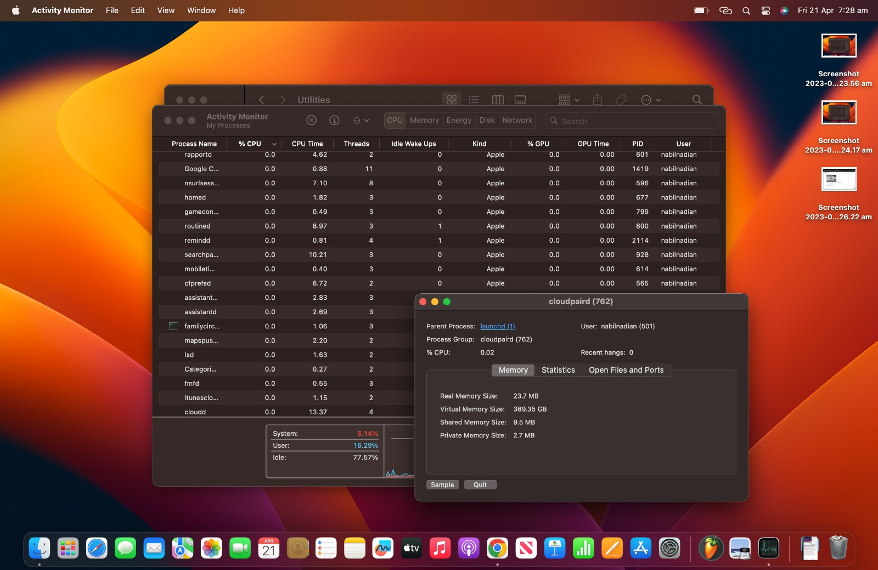

It can be seen that it is using a very minimal amount of CPU Which is only .02%. Also, it uses 23.7 MB of RAM but it uses a huge amount of virtual memory which includes the use of both hard disk and RAM. It also uses some shared memory and a small amount of private memory. In brief shared memories data can be accessed by multiple processes on the other hand data of private memory can’t be accessed by anyone apart from the process itself.

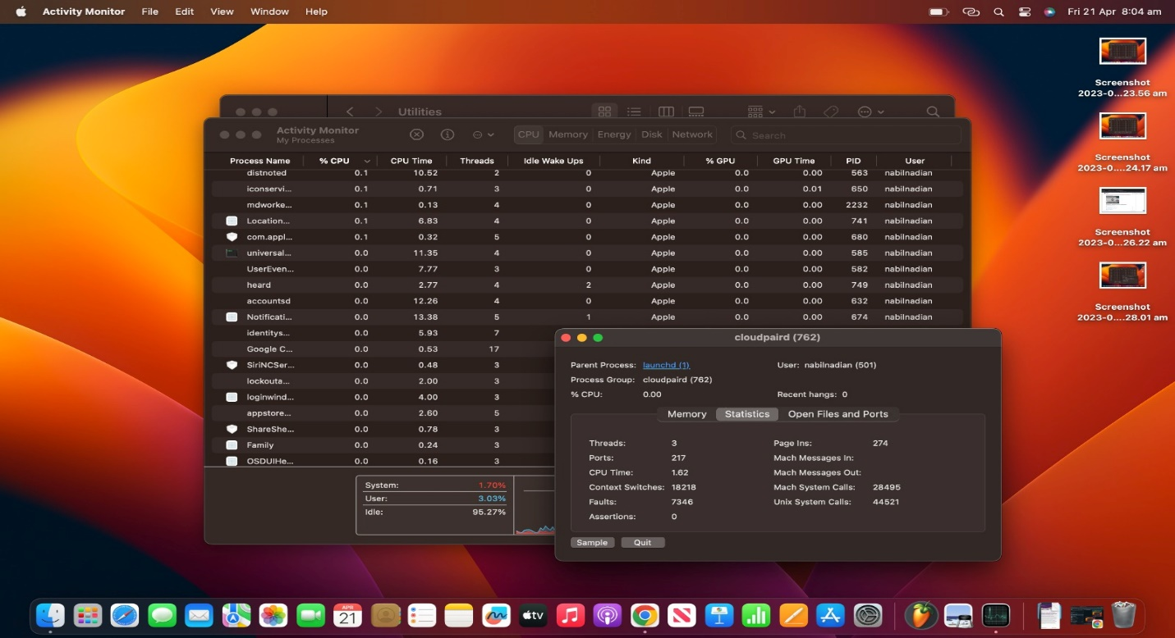

Some more information can be found in the Statistics tab such as the number of threads it is using, the number of ports that are opened by the process also the amount of CPU time spent on this process, and some other information.

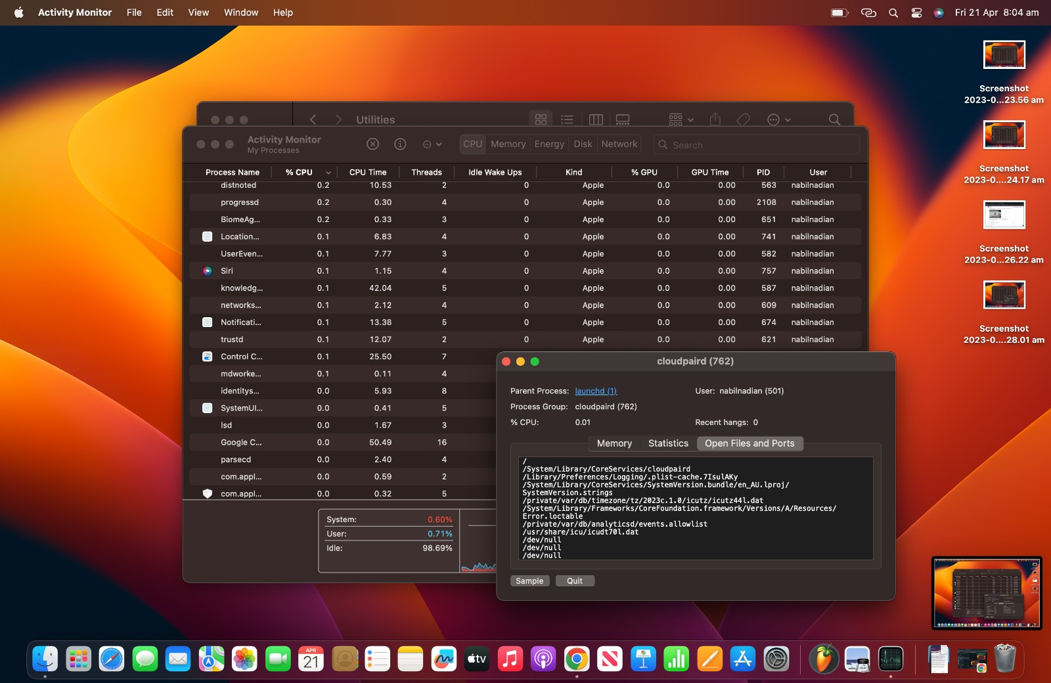

In this tab, the opened files and port details are given for a more detailed overview.

### ANS 3.

An application might create and manage multiple types of files. So some strict rules must be followed to maintain consistency for those files. Otherwise, the files created by one application can’t be managed by another application when needed or in some cases can also be lost. Such an example can be a PDF file.

When the OS manages files it applies rules to make sure that the files maintain consistency and also provides additional security to the files. Also, it provides a centralized and easy way to restore and back up the files which makes the whole experience of working with data and files more stable and secure.